TRADER (PHP)

1. For Trader Login, firstly you need to be on homepage of CleckShopHub, and then you can find Login labelled button at the navigation bar on top right.

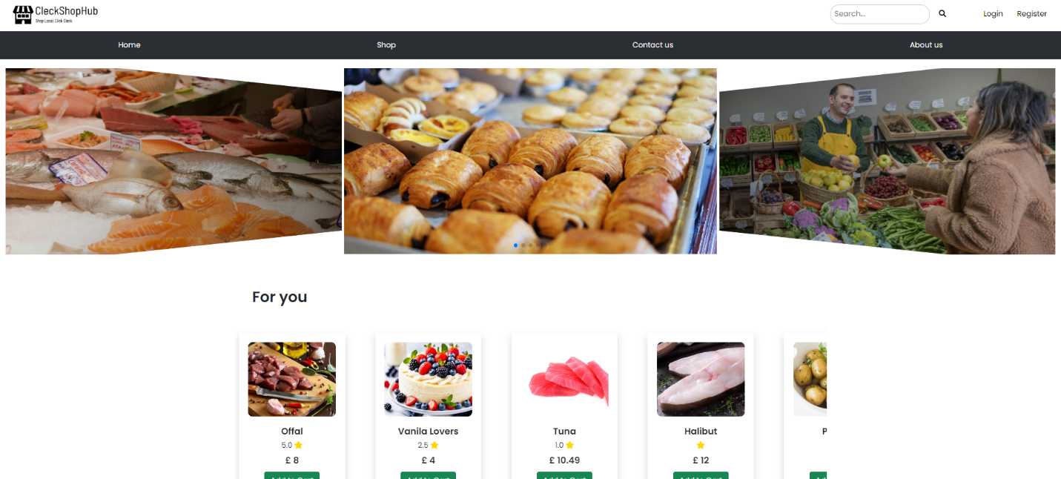

1. Click on the LOGIN button and then fill in the form with trader login credentials as shown:

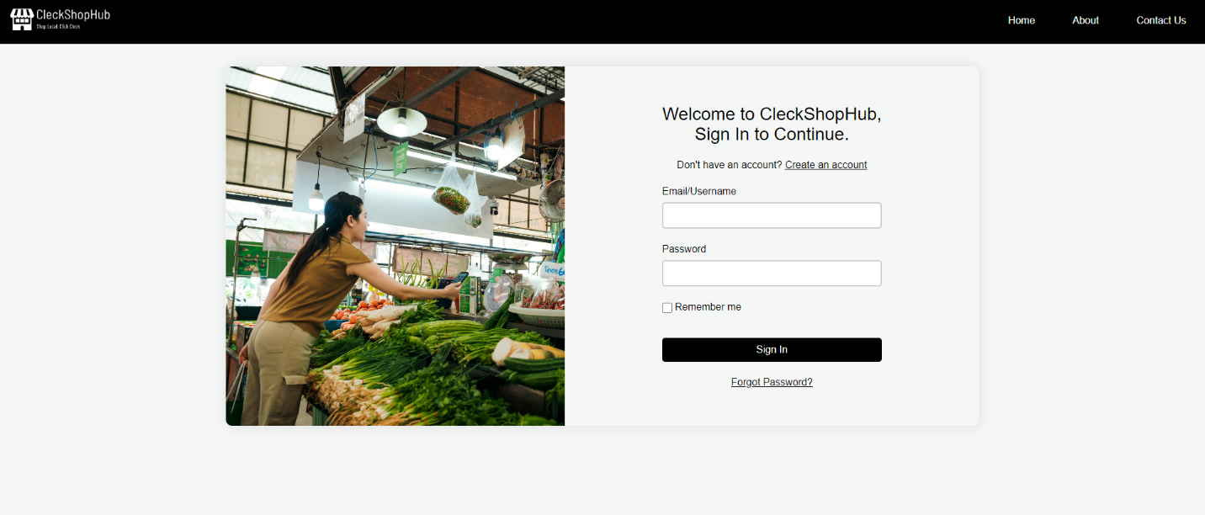

1. Once the correct trader login credentials are filled, you will see a page with dashboard that’ll look something like this. The dashboard includes details such as number of total and pending orders, reviews and the amount of products in their shop, which is crucial for traders.

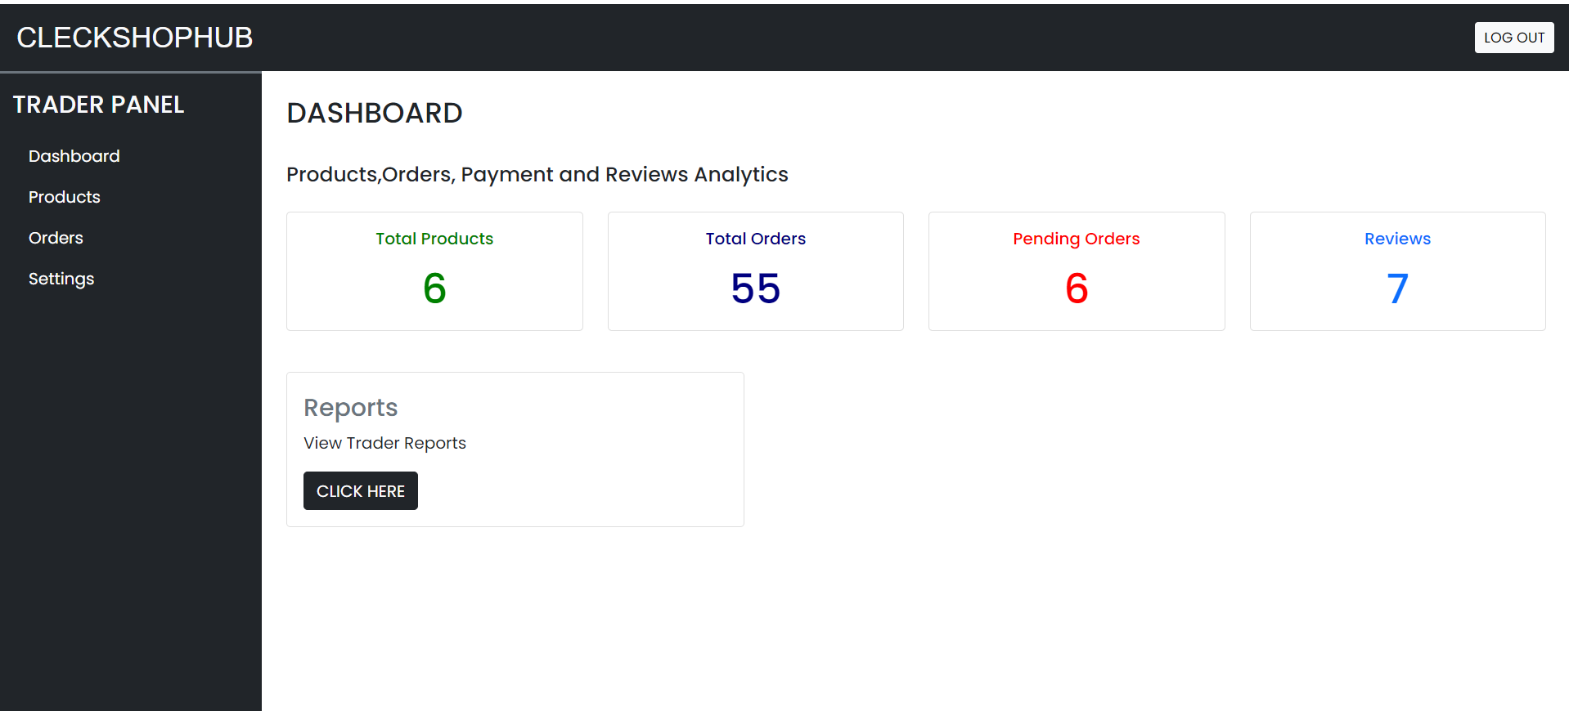

1. You can view all the product in your shop by clicking on the Products tab on the left side

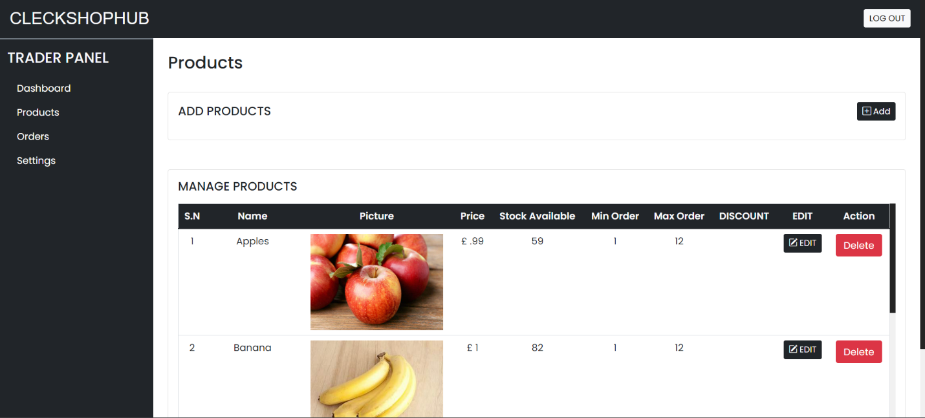

1. If you wish to edit or add products in your shop then click on the edit button then a pop will appear where you can edit the product details such as product name, amount or the description as well as the product image.

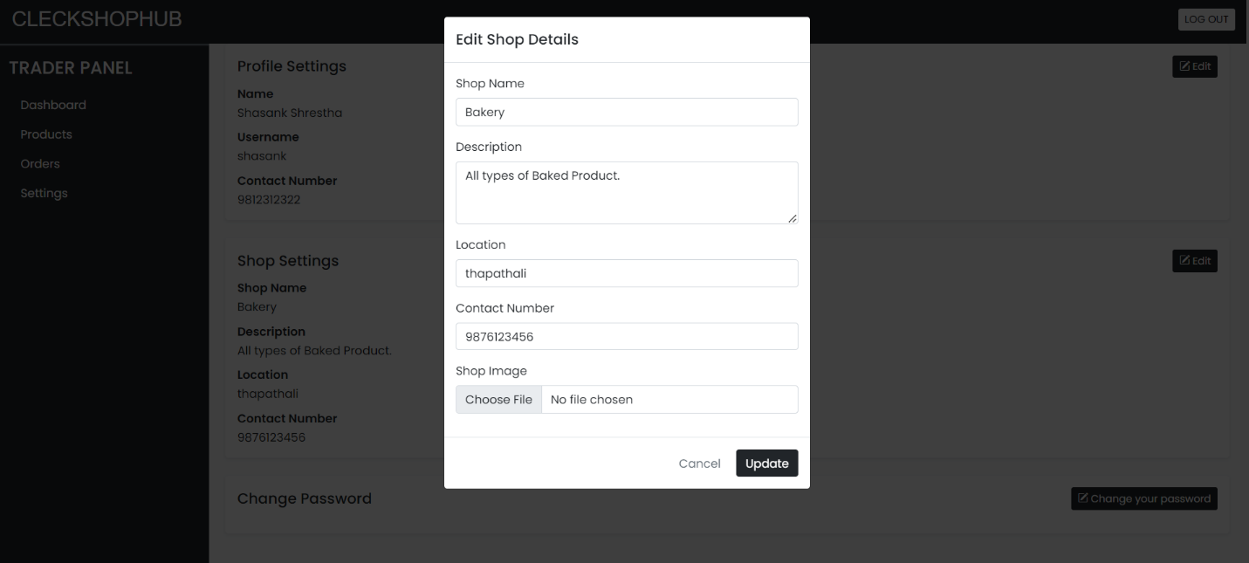

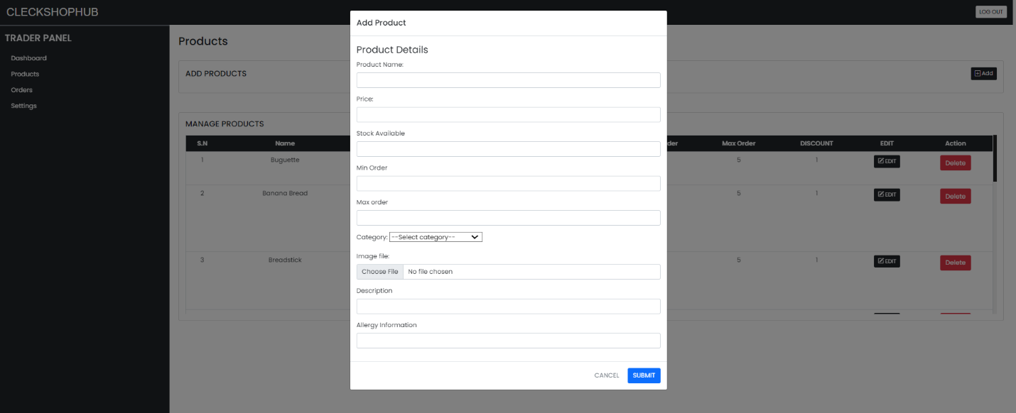

1. You can check all the orders customer has made by clicking on the Orders tab.

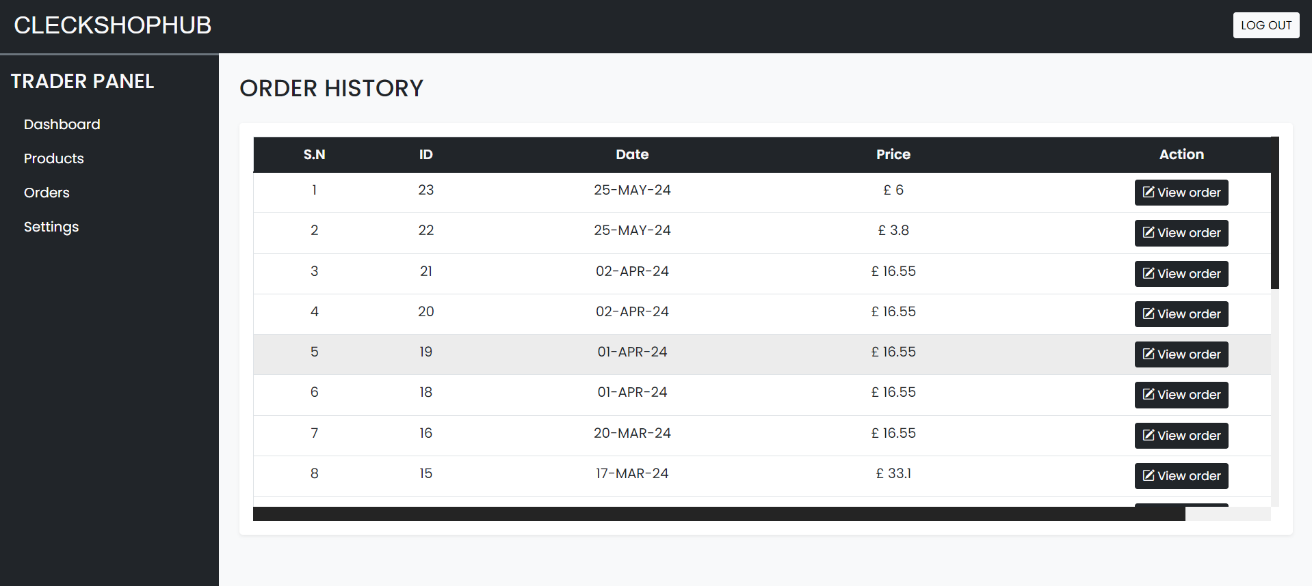

1. After clicking on Settings tab, you can view your Personal profile details such as first name and username and contact number, and the shop setting can be seen right below along with the Change password section.

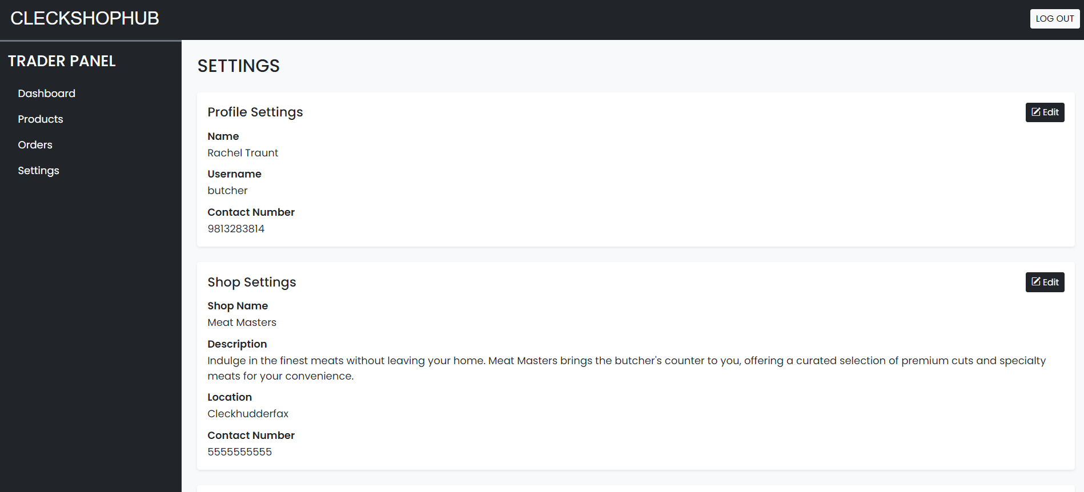

1. If you click on the Edit labelled button you can your details such as Personal and Shop Details as shown below

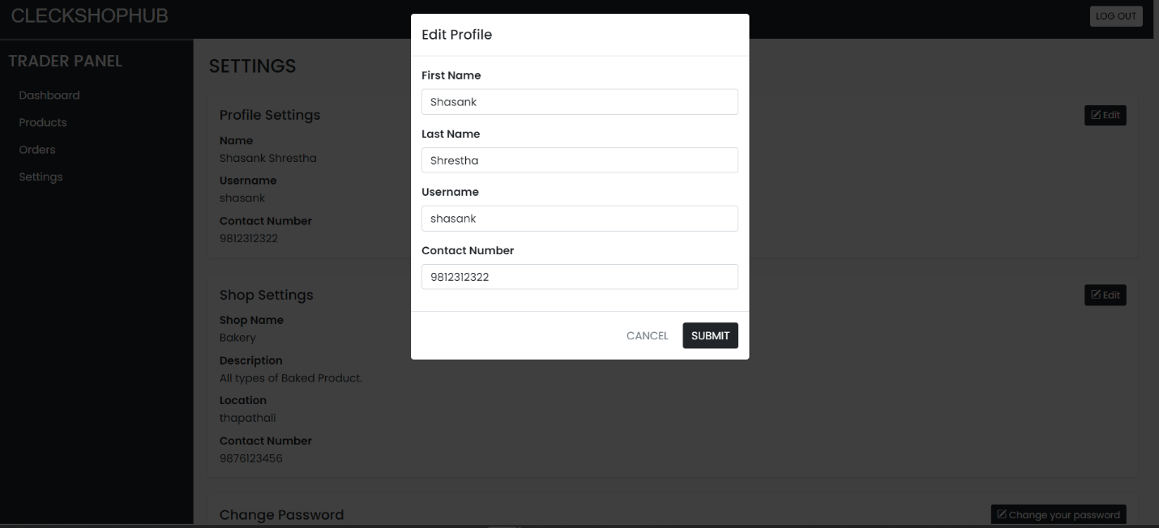



1. If you wish to change your password you can press the edit button, then a popup will prompt you to enter your old and new password.

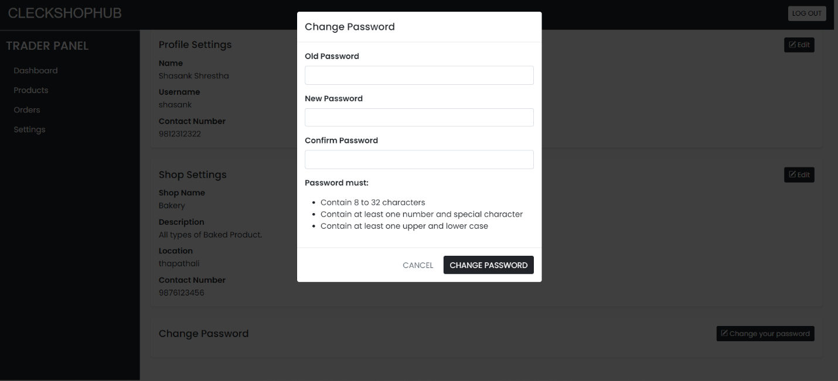

1. 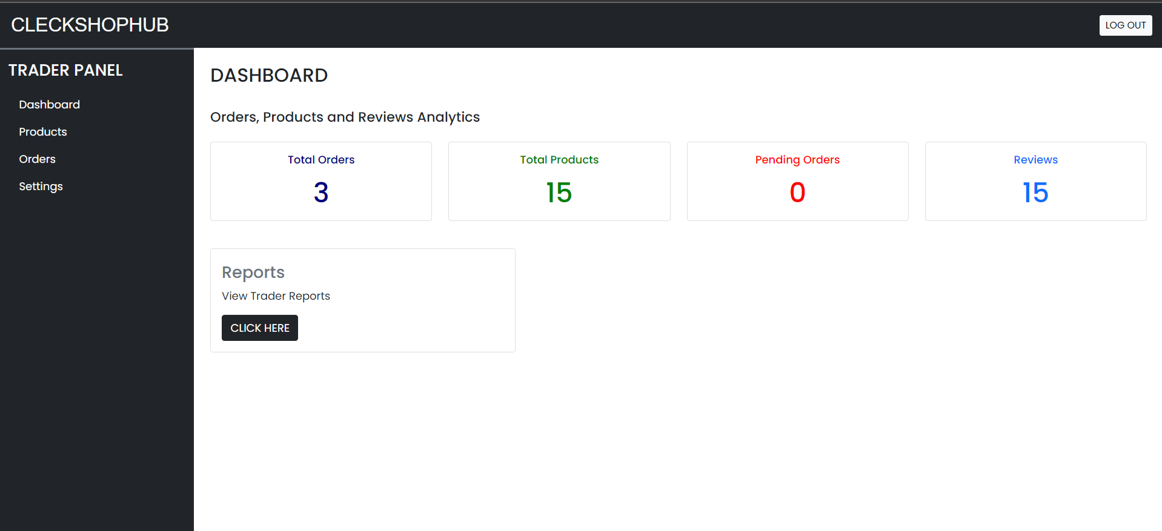You can log out by pressing the log out button on top right of the navigation bar.